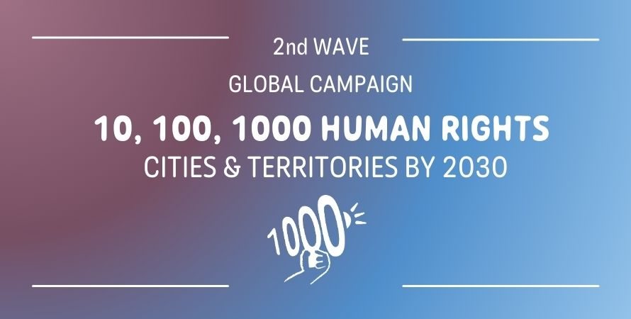

JOIN THE CAMPAIGN!

FORM

- General Information

Name of the local/regional government:
Country:
Number of inhabitants of the local/regional government:
Type of local/regional government:

- City/Municipality
- District
- Region
- Province
- Metropolis
- Other:

Name and position of the head of the local/regional government (Mayor; President; Governor; etc):

Mandate duration:

Name of the designated focal point for the campaign:

Email:

- Your vision as Human Rights City/Territory

Why are local and regional governments essential to promote, fulfill and respect Human Rights? Why Human Rights are meaningful values and a useful framework to guide your local action? (700 words max)

- Main areas of focus

- Accessibility  - Accountability and transparency  - Anti-racism  - Basic Services (including the rights to water, sanitation…)  - Climate and environment  - Culture and cultural rights  - Digital rights  - Equality and fight against poverty  - Inclusion of marginalized groups (migrants, homeless people, etc.) | - Historical memory, peace culture and security  - Housing  - Human Rights Education  - Non-discrimination and anti-xenophobia  - Participatory Democracy  - Public Health  - Right to food and Food security  - Right to Education  - Women  - Youth and Children  - Others (please specify):

- Motivations to join the campaign
(100-200 words)

- Local laws, mechanisms, policies and programs (optional)

Briefly share 1 to 3 examples of actions you are implementing that advance the realization of human rights at the local level (weblinks or documents can be attached). The examples should refer to different areas of focus (see point 3.)
1)
2)
3)

- Statement of commitment

I, (NAME and POSITION), as representative of_______________ ( NAME of the local/regional government), would like to support and join the global campaign “1o,1oo,1000 Human Rights Cities and Territories”. Through this statement, the city/territory of____________________________ (NAME of the local/regional government) acknowledges its commitment in advancing human rights’ locally; to promote the role of local and regional governments -as closest level to the people- in protecting and fulfilling these rights; as well as to participate in the international movement of “Human Rights Cities and Territories”.

Date / / 2022

Signature

